WARAPORN DOUNGPRAKHON (Champ)

26,Moo18 ,sawaijeek ,Mueang , Buri Ram, Thailand, 31000. Thai Mobile: (66) 0656586864
Email;doungprakhon81@gmail.com

Personal Profile

Date of Birth : September 10, 1981 Height : 158 cm
Weight : 50 kg

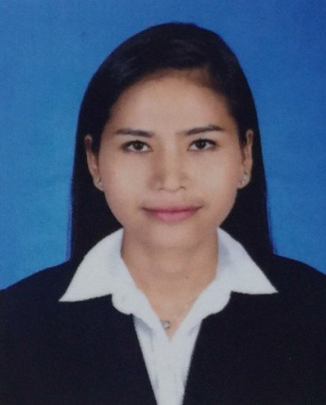Status : Single Nationlity :Thai Religion : Buddhism Education
Finished Senior High School

At sawaijeek Pittayakom School in BuriRam,Thailand

Career Objective

To be an important part of a professionally managed company, where I can lead people with the knowledge and experience I hold with my work while attaining higher education and relevant skills

And contributing productively for the growth of the company

Skills of work

- Thai massage
- Thai herbal compress
- Swedish massage
- Aroma therapy massage

- Balinese massage
- Hot stone massage
- Bamboo massage
- Candle massage
- Four hands massage
- Indian head massage
- Deep tissue massage
- Sport massage
- Pregnancy massage
- Lymphatic drainage
- Shiatsu
- Watsu
- Hammam

- Slimming treatment
- Foot reflexology
- Pedicure, Manicure , Gel application
- Body Treatment, Body scrub, Body wrap
- Waxing
- Eyelash and eyebrow TinTin

Work Experience

Cheval Blanc Randheli Maldives (LVMH): (1 June 2013-31 May 2019) : Beauty Coach Responsibilities:
- Provided Body massage, body treatments, Facial treatments by Guerlain
- Promoted and delivered courteous, efficient and memorable service to the guest
- Maintained and ensured cleanliness of massage equipment and spa rooms
- Scheduled appointments, performed check-in and check-out of clients, greeted and escorted spa guests
- Opening Spa Operation and Closing

SensAsia Urban Spa Dubai :(1 September-30 January 2013) :Spa therapist Responsibilities
- Provided Body massage, Body treatments
- Promoted and delivered courteous, efficient and memorable service to the guest
- Maintained and ensured cleanliness of massage equipment and spa rooms
- Scheduled appointments, performed check-in and check-out of clients, greeted and escorted spa guests

Banyan Tree Hotel Phuket (December 2009-March2012 ): Spa therapist

Responsibilities
- provided Body massage, Body treatments, Facial treatments Expert in Swedish massage, Aroma therapy massage , Sport massage, Thai massage and Javanese massage

- Handle guest queries and concerns efficiently
- Uphold the standards of hygiene and sterilization as directed by the law and spa policies

Korea Day Spa (May 2008-April 2009): Spa therapist Responsibilities
- Body massage and Body treatment, Foot massage, Facial treatment. Training
- Cheval Blanc Randheli Maldives Guerlain Training for Facial treatment, Body treatment and Body massage.
- Cheval Blanc Randheli Maldives Guerlain Training for Randheli Products as Perfume, Skincare and Cosmetic.
- Cheval Blanc Randheli Maldives Recognition of your valuable contribution during the pre-Opening period and for all efforts towards the successful opening on 15 November 2013.
- Cheval Blanc Randheli Maldives Associate of the month on January2017
- Banyan Tree Resort and Phuket Academy in house Training.
- Wat Po Academy Bangkok Thailand of 2009 for Thai Massage, foot Massage, Aroma massage from a massage Certificate.

Certificate

- The Wat Po Traditional medical school of foot massage, The Wat Po Traditional medical school of Thai massage, The Wat Po Traditional medical school of Oil massage.
- Ministry of Public Health Thailand.
- Guerlain Methodical Authentics Training and Guerlain Retail Product Traning.
- Diploma introduction to Spa Manager from Dhurakij Pundit University.
- Anatomy and Physiology from Chiva-som International Academy.

Skill @ Language Ability

- Thai
- English

