PROFILE

Miss Kanyaphat Laokham
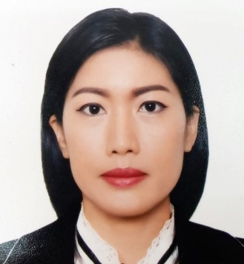
47 Moo 6 Nongthong, Saingam, Kamphaeng Phet, Thailand.
Mobile Phone : +66(0) 81-6461465
Email : kanjanahirsch@gmail.com

PERSONAL INFORMATION
Birthdate : 16/04/1979
Age : 40 years
Height : 153 cm.
Weight : 48 kg.
Nationality : Thai.
Status : Single.
Education : Bachelor's degree.
Kamphaeng Phet Rajabhat University.

Objective Seeking a position as a Spa Therapist wherein my skills and abilities can make effective contribution in providing excellent massage therapy.

2017 – 2019
Ocean club fitness & Spa ( Spa Therapist )
Istanbul, Turkey.

2016 - 2017
D.O.Spa & Bueaty Massage, ( Spa Therapist )
Bangkok, Thailand.

• Performs massage and body treatment that meet the established guidelines for the type of service offered in menu.
• Observed client reactions to massage and modified as necessary
• Follow all safety and sanitation policies.
• Keeps track of regular clients’ progress.
• Follow departmental policies and procedures.
• Other duties as assigned.

• Proven ability to gain customer’s confidence and trust.
• Excellent verbal and written communication skills.
• Possess excellent organizational and time-management skills.
• Enthusiasm and have outstanding customer service skills.
• Skilled to resolve all customer issues.

• Proficient in spoken and written Thai.
• Ability to communicate in English.
• Thorough knowledge of computing system ( Words, Excels )

1. Thai massage 150 hrs.
2. Spa for Health and Beauty 250 hrs.
3. Aroma Therapy 150 hrs.
4. Relaxing Foot massage 60 hrs.
5. Skill standard testing of NUAD THAI PRACTITIONER
(TRADITIONAL THAI MASSAGER) Of Level 1.

• Thai massage / Aroma massage / Foot massage / Facial massage / Swedish
• Hot stone / Slim / Herbal Compress massage / Body scrub / Hamam bath

• Samer Laokham Tel: +66(0) 80-5770199
WORK EXPERIENCE

Duties and
RESPONSIBILITIES

Qualifications
Summary

Additional skills
Language

Computer

Certificate

Massage Skills

REFERENCE

