PERSONAL DATA
Date of Birth: ​​17 MAR 1984
Nationality: ​​Thai​
Religion: ​​Buddhist
Sex:​​​​ Femal
Height:​​​ 158 cm
Weight: ​​57 kg
Health:​​​ good
Mobile:​​ +66955320998

Experience
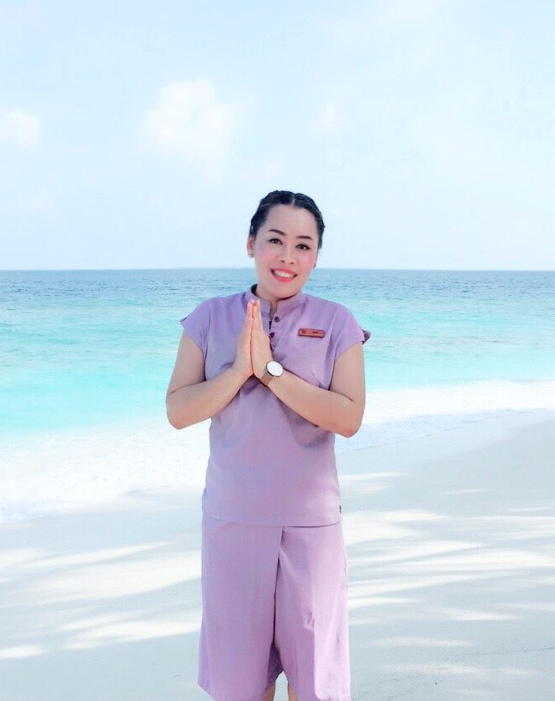

Warin Thongphithak

Objective
Obtain a challenging position that will utilize my 10 years in Spa experience for the benefits of my future employer and further develop my career

Skills & Abilities

Thai Massage
Foot Massage
Aromatherapy Massage
Body Treatment
Herbal Compress
Back & Shoulder Massage
Head & Shoulder Massage
Reflexology
Swedish Massage
Face Massage
Hot Stone
Slimming Massage
Turkey shower

2018-Present

DAVARANA SPA DUSIT THANI MALDIVES

POSITION: SPA THERAPIST

Dusit Thani Maldives Mudhdoo Island Baa Atoll

2017 - 2018

Chang Foot Massage Langsuan

POSITION: SPA THERAPIST

29/1 soi Langsuan Phloen Chit Rd.

E-mail. Changfootmassage @gmail.com

Tel: +6622533977

2013 - 2016

SABAI THAI SPA HOTEL NEW MARRION

POSITION: SPA THERAPIST

6 JAPANTH,BHUBANEWAR INDIA 751001

WWW.SABAITHAISPA.IN

EMAIL: CONTACT@SABAITHAISPA.IN

tEl:9090989090,PH : +916742380805

2010 – 2012

Massage Me Massage and Relaxation Center
POSITION: SPA THERAPIST
Dubai Deira Abu hai be-hind Deira Post Office

Tel: 042664441 050141120

2007 - 2010

The Best Massage & Relaxation center.
POSITION: SPA THERAPIST
323/20 Moo. 10, Soi 13/3 pattayaland,Rd,Nongyree Banglamung Chomburi Thailand 20150
E-MAIL N-E-E-A-T @HOTMAIL.COM
TEL : +6685085255

Education

​

Bachelor's degree Food Science

Institute: Rajamangala University Of Technology Isan Surin

Year of Graduation: ​2006

OTHER TEAINING

-Tropical Thai Medical Institute.
- Thai Massage
- Foot Massage
- Aroma Massage
- Oil Massage
- Hot Herbal Compress ( 600 hrs )
-.Thai Massage (150 Hours) 3.Teaming for receptionist

