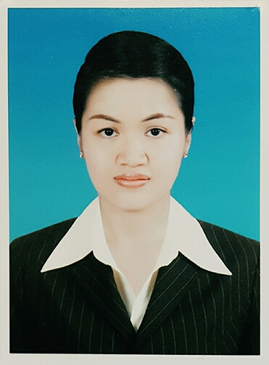
Resume application for spa therapist
Miss Vanittada Narmphao
Address. : 33 Moo5, Yoonok, Chiangsaen, Chiangrai Province, 57150
Mobile number : +66 628819682
E-mail address : Lovelyployy@windowslive.com, Vanittada35@gmail.com
Skype : Lovelyployy@windowslive.com

Personal Data
Sex female
Date of birth November 20, 1979 , Chiangrai Province , Thailand
Marital status single
Nationality Thai
Religion Buddhist
Height 155 cms.
Weight 48.5 kgs.
Passport no. O505561

Education Degree : Bachelor’s degree of Art, major Community Development from Chiangrai
Rajabhat University, February 2003, Chiangrai Province, Thailand

Working Experience
Jan 2016 – 23Jan 2017- working at Ce Shine Spa , Huapont hotel and resort, Fairy
moutain, Chongqing , China
June 2015 - 25 Nov. 2015 - Work at Thai Spa (Luxury Spa), Vladivostok Russia.
(position: spa therapist)
June 2014 - 30 Mar. 2015 - Worked at Zvezdakino Yoga and Spa Ltd., Tomsk, Russia.
(position: spa therapist)
Mar. 2013 - 28 Mar. 2014 - Work at Lotus Thai Spa , Naro-Fominsk , Moscow, Russia
(position: spa therapist)
Mar.2012 – 16 Dec. 2012 - Worked at White Orchid Spa ,Yubileinaya Hotel, 10 Altayskiy Str.
Yuzhno-Sakhalinsk, Russia
(position: spa therapist)
Oct. 2010 – 31 Aug. 2011 - Worked at The Oberoi hotel and resort,Trident hotel
(five star hotel in India), Gurgaon, Delhe, India
(position: spa therapist)
Sep. 2009 – Mar. 2010 - Worked at Axioma –Thai Ltd. Devarana spa , 9/12 tenistaya str. Odessa
Ukraine 65000
(position: spa therapist)
Apr. 2008 – Mar. 2009 - Worked at Axioma –Thai Ltd. Devarana spa , 9/12 tenistaya str. Odessa
Ukraine 65000
(position: spa therapist)

Feb. 2008 – Mar. 2008 - Worked at True spa at Zen, Central World
(position: spa therapist)
Mar. 2006 – Nov. 2007 - Worked at Thai Privilege spa, the office at Central World , Bangkok Thailand
(position: spa therapist)

Training
Dec. 2015 - Traditional Thai massage 372 hours from The Union Of Traditional Medicine
Society , Thailand
Mar. 2011 - Ayurvedic spa treatments Sundary product
The Oberoi Gurgaon , India
10 Dec. 2010 – 14 Jan. 2011 - Training the Oberoi standard spa treatment and product,
Omorovicza facial and body treatment , Lembency Academy Noilda ,India
22 Aug. 2007 - Knowledge and skill of level 1(basic standard of Thai traditional massage)
from Department of Skill Development, Thailand
Mar. 2006 - Traditional Thai massage (Nuad Thai 150 hours)
from Thai traditional Medical Service Society, Thailand

Skill
Massage
-Traditional Thai massage
- Foot reflexology
- Foot massage
- Aroma massage
- Thai herbal
- Balinese massage( Thai with oil)
- Facial
- Face and head
- Hot stone therapy
- Hot lava shell
- Slimming
- Body scrub
- Body wrap
- Indian Traditional Ayurvedic
- Pregnant therapy
- Deep tissue
- Swedish
Computer : Ms. word, Internet, Photo Scape
Typing : Thai 30 words per 1 minute, English 30 word per 1 minute
Knowledge Language
Thai : very good (listening/ speaking/ reading/ writing)
English : good (listening/ speaking/ reading/ writing)
Russia : basic (a litle speaking)
Chinese : basic (a little speaking)

